LIVING WATERS CAMP
Rental Manual

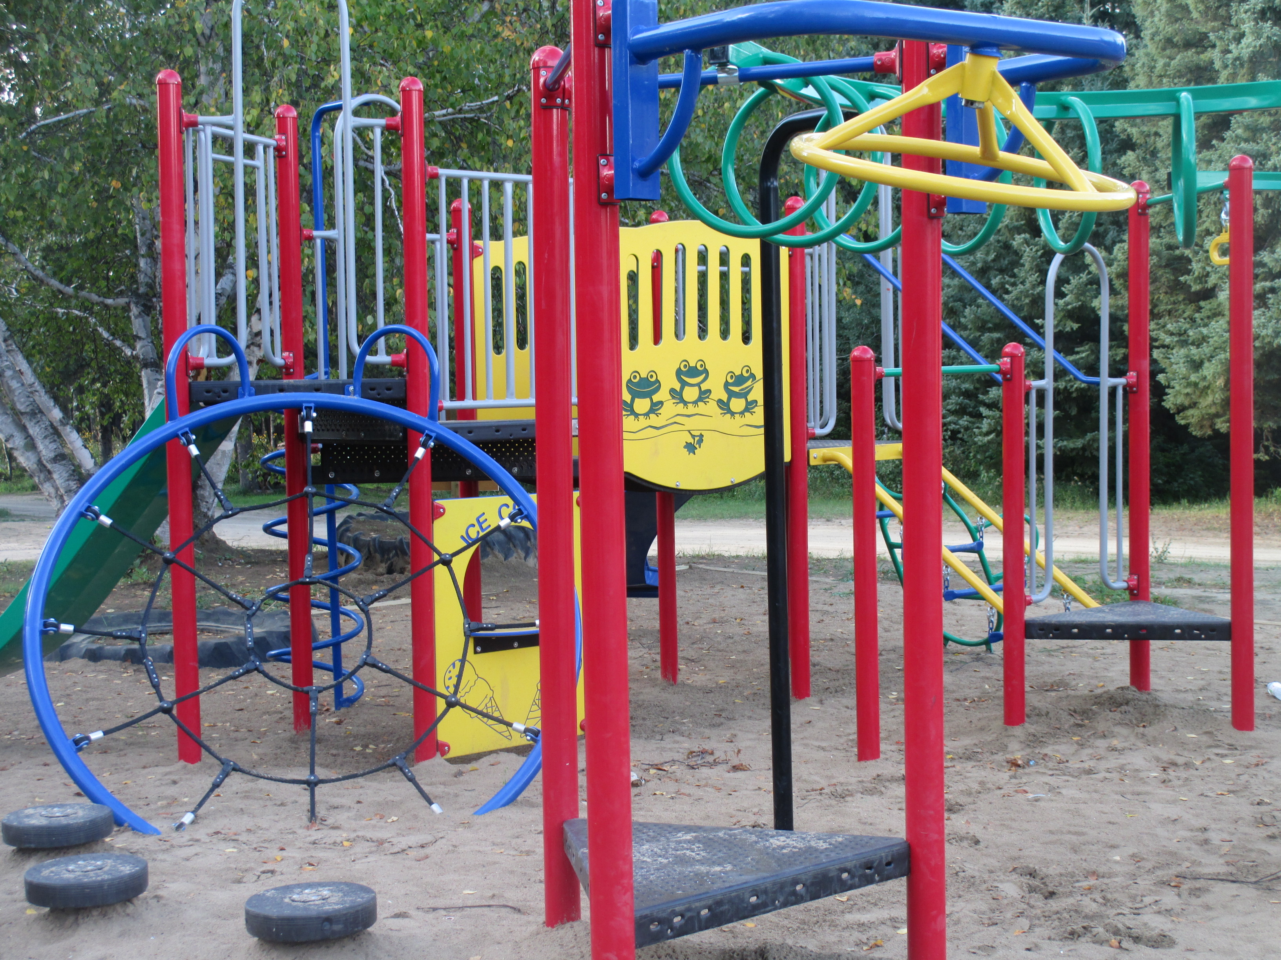

www.livingwaterscamp.ca

Email: livingwaterscampsk@gmail.com

Office phone/Reservations: 306-683-4646
1303 Jackson Avenue
Saskatoon, SK S7H 2M9

Living Waters Camp is owned and operated by the Pentecostal Assemblies of Canada, Saskatchewan District. The camp was established in 1942 to assist its churches in spiritual training through a camping program.

Living Waters Camp is located one hour north of Saskatoon on Highway 11, five minutes south of MacDowall and twenty minutes south of Prince Albert, Saskatchewan.

The camp is nestled in 30 acres of pine and aspen bordering Adamson Lake.

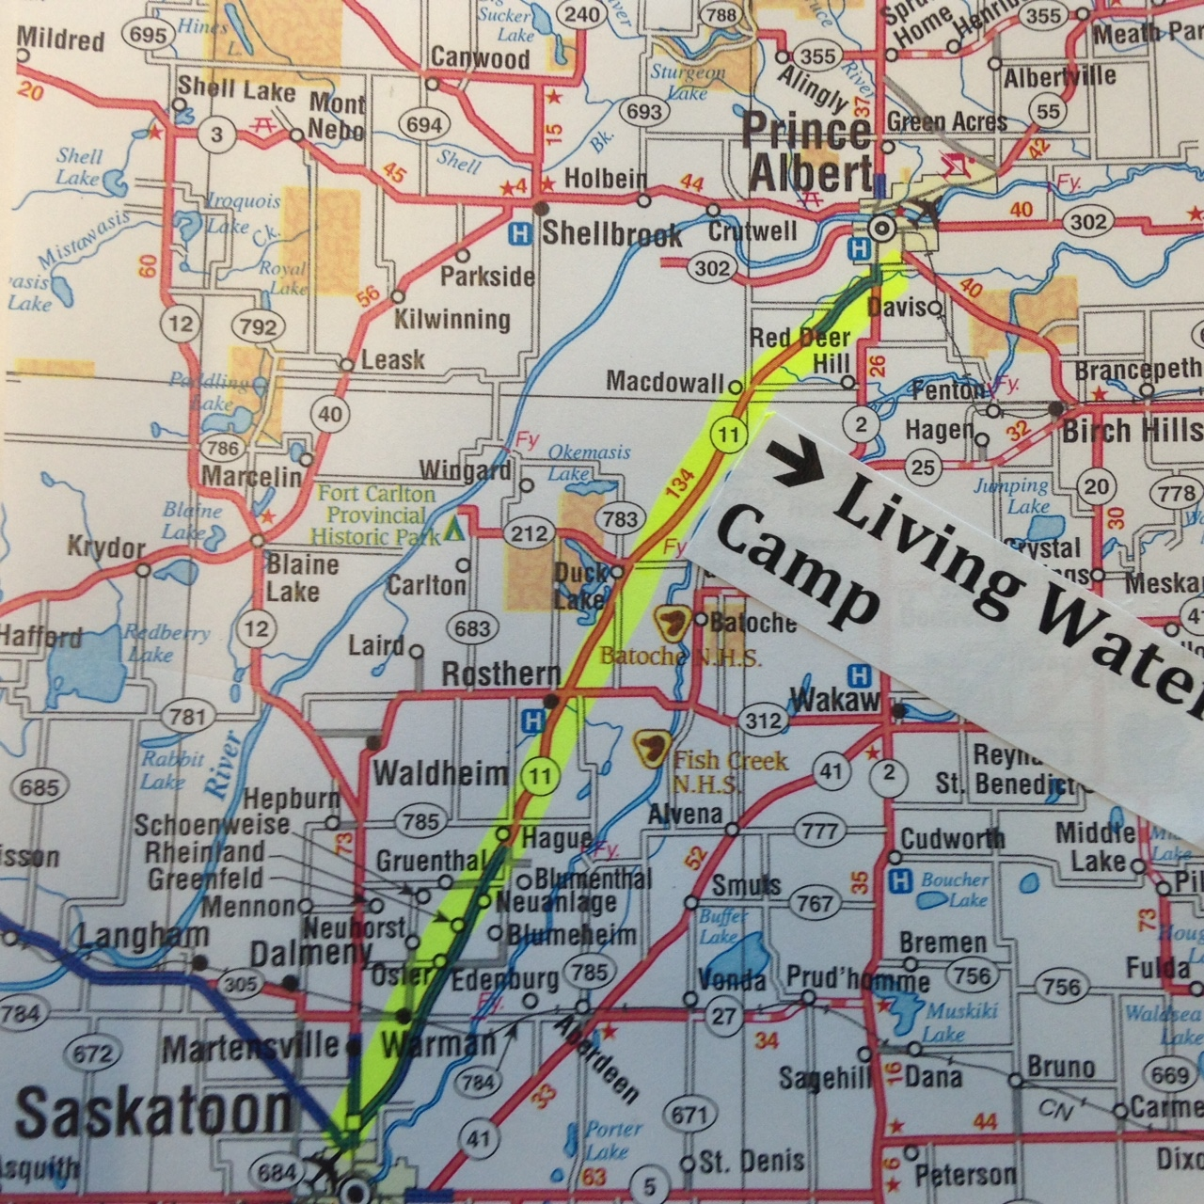

Accommodations

Bedding: The camp provides beds and mattresses. Guests must bring personal bedding, including pillows.

LODGE
The winterized lodge is located in the centre of the camp. It is a nine-bedroom facility with two beds and a desk in each room (each room sleeps maximum 4). There are two shared full bathrooms (men’s and ladies) with three toilets, two sinks and three showers in each. You are required to bring your own bedding and toiletries.
$65/night/room

CABINS
The cabins are located beyond the tabernacle by the lake. All have a small deck or seating area outside (bring your own lawn chairs).

Duplex (one available) – two rooms with shared bathroom between
$40/night per side
One Room Cabin (seven available) – accommodate two people (one bed) with private bathroom
$55/night/cabin
Two Room Cabin (four available) – bedroom, sitting area and private bathroom.
$65/night/cabin, $75 for cabin with A/C

COTTAGES
The cottages are located to the left of the road when first entering the main part of the campground, across from the playground. Each one has a seating area. The bathrooms have a shower and sink but no toilet.
Two bedroom (one available)
$50/night
Three bedroom (two available)
$60/night

MOTEL
The motel is located across from the lodge and has two guest rooms with a queen bed in each and a full bathroom.
Side one - $60/night
Side two – with air conditioner - $70/night

DORMS
The five dorms are located behind the central bathroom, near the basketball court.
All the dorms have electricity.
Dorm One – 8 rooms with 1 twin bunk and 1 double/twin bunk per room; a shared half bathroom is in the building
Dorm Two – 8 rooms with 2 twin bunks per room; a shared half bathroom is in the building
Rates for Dorm 1 and 2: $20/person/night or $40/family/room/night
Dorm Three – 8 rooms with 2 twin bunks per room
Dorm Four – 8 rooms with 1 twin bunk and 1 double/twin bunk per room
Dorm Five – 5 rooms with 5 sets of twin bunks sleeping ten per room
Rates for Dorms 3, 4 and 5: $15/person/night or $30/family/room/night

There will be a $40 replacement charge for lost keys and a $60 replacement charge for all missing or damaged mattress covers.

CAMPSITES/RV SITES
We have 65 campsites. Sanitary disposal site is available. A public washroom with showers is located in the middle of the RV sites.

$12/day for unserviced site
$25/day for 15 amp power and water
$32/day for 30 amp power and water
Seasonal rates of $375/month or $1200/season May-Sept

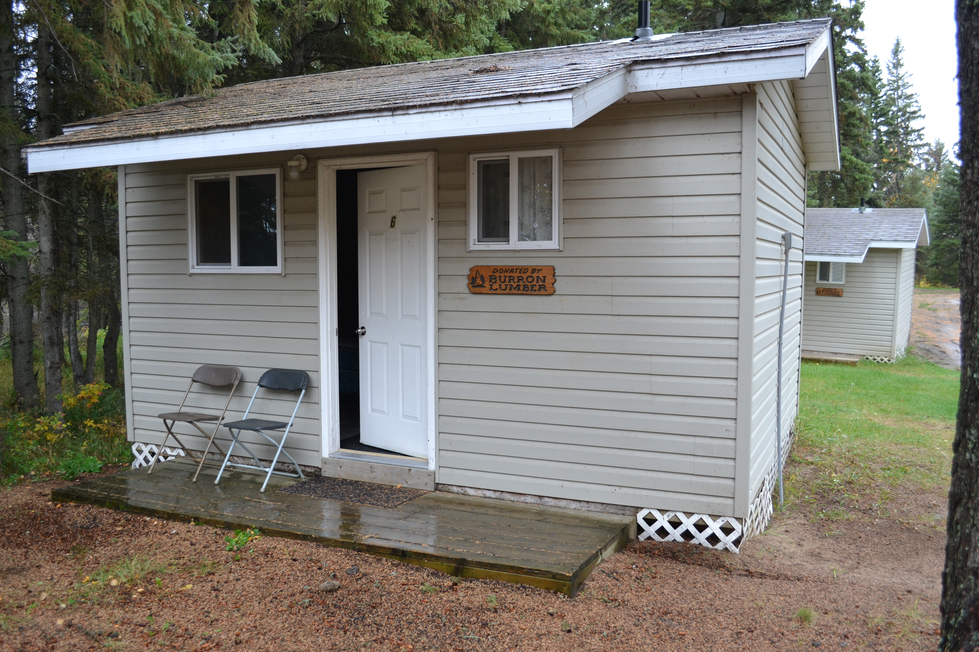

PUBLIC BUILDINGS

FELLOWSHIP CENTRE (Canteen)

The winterized Fellowship Centre (Canteen) is located across from both the Dining Hall and Lodge. It has seating for 40 around café style tables or for 50 lecture style (there is a TV screen for data projection). There is also a coffee counter area and a welcoming environment by the stone fireplace. The attached kitchen is available for cooking for smaller groups and for service of concession items. It contains a fridge, freezer, deep fryer and a standard stove. There is seating outside for many more on the patio (weather permitting).

Kitchen and Seating area - $125/day
Seating area only - $100/day

KITCHEN/DINING HALL
The dining hall with the attached kitchen is located in the centre of the camp. It has seating for approximately 200 people. The kitchen is fully equipped. No food or kitchen staff are included in the rental agreement.

Kitchen/Dining Hall - $175/day

TABERNACLE
The main tabernacle has seating for approximately 400 people on wooden pews. A sound system is also available for renting.

Tabernacle - $150/day
Tabernacle with sound equipment - $200/day

CHAPEL
The chapel is located near the lake. It has a maximum seating capacity of 100 so it is suitable for smaller groups.

Chapel - $100/day
Chapel with sound equipment - $125/day

PRESCHOOL
The preschool room is located in the centre of camp, in a room at the end of the motel building. It has a dedicated washroom, play and craft area (supplies not included) and a fully enclosed outdoor play area.

Preschool - $60/day

RECREATIONAL FACILITES AND EQUIPMENT

Canoes
There are canoes and paddleboards available for rental at $10/day for individual rentals, or $30/day for group access. Life jackets are included in the rental.

On Site Activities
- Swimming (sandy beach)
- Basketball/pickle ball court
- ground trampoline
- group bonfire area
- playgrounds
- gaga ball
- horseshoes
- soccer/baseball pitch
- bouldering wall

Some sports equipment is available. A $50 deposit is required to sign out the sports equipment. This will be returned after the camp if all items are returned in useable shape.

Please note:
You are using the facilities at your own risk. Liability insurance must be provided by the renter.

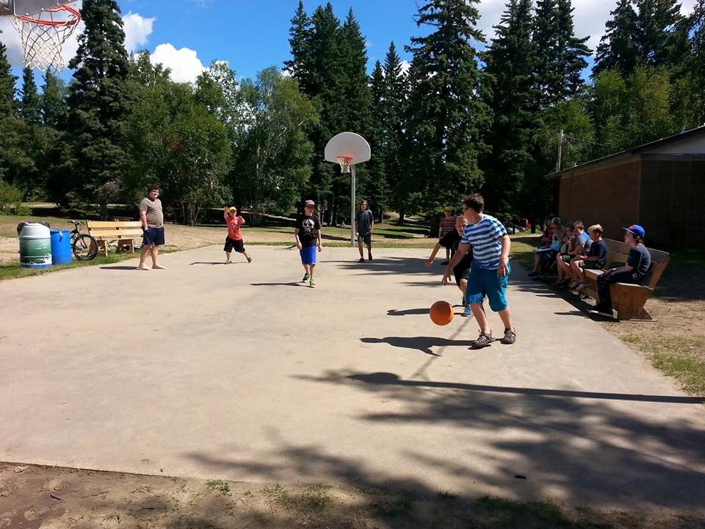

Rental Policy

Living Waters Camp has been dedicated to the glory of God as a centre for the purpose of facilitating camps, conferences, and family gatherings for religious and educational purposes. Our primary purpose is to challenge and build into the lives of people of all ages, in a relaxed and healthy environment.

The premises of Living Waters Camp are to be used for activities in keeping with the community life standards of the Pentecostal Assemblies of Canada.

Acceptable functions include, but are not limited to: Christian worship services and activities, Christian weddings, missions activities, educational camping activities and family celebrations. LWC welcomes retreats for schools, community groups, businesses and personal retreats.

The premises of Living Waters Camp are not to be used for the carrying on of business or for activities that are contrary to the community life standards of the Pentecostal Assemblies of Canada (including but not limited to gambling, consumption of liquor or the use of illegal drugs).

Camp management reserves the right to determine violation of these principles and apply punitive measures if required (i.e. expulsion from Living Waters Camp property). Offenders can appeal this decision to the LWC Council if they choose to do so.

